Global ICT

Power Generation Digital Hub / Digital Satellite Colombia and Peru

|  |
| --- |
|  |
| Carga datos de embalse Guavio medida rio Batatas desde Interfaz INGEN a GREPORTING Power Generation  Requerimientos funcionales  Versión 1.0 |
| SM100-User Requirements |
|  |
|  |
|  |
| This document contains proprietary information of Enel SpA and shall only be used by the recipient in relation to the purposes for which it was received. Any form of reproduction or disclosure without the express consent of Enel SpA is prohibited. |
|  |

|  |  |  |
| --- | --- | --- |
| Written by | **Nova Chávez, Hugo Yusef** – Global Power Generation Digital Hub | 29/09/2020 |
| Verified by | **Ramirez Alaguna, Cesar Augusto**/ / O&M Improvement Colombia and Peru | 29/09/2020 |
| Approved by | **Ramirez Alaguna, Cesar Augusto**/ / O&M Improvement Colombia and Peru | 29/09/2020 |

|  |  |  |  |  |  |  |
| --- | --- | --- | --- | --- | --- | --- |
| **Project Info** | | | | | | |
| **APM Code** | | |  | Application code defined in APM | | |
| **Applicant** | | |  | With this driver, the source for the initiative set up is identified. Choosing between internal or business initiatives implies that actors will be different and/or involved differently in the initiative set up and development. | | |
| **Initiative Type** | | |  | Initiative Type is a driver used to evaluate what type of initiative is going to be set up, depending on the need for an infrastructural or applicative initiative. | | |
| **Development Type** | | |  | Development Type is a driver that differentiates the initiatives based on their intervention perimeter relatively to budget, men days and impact on the overall system. | | |
| **Methodology** | | |  | Methodology used for the project. | | |
| **Incident categorization (Only for Correctives)** | | **Impact** |  | Service downtime impact on the Business, to be estimated considering the potential damage coming from an extended service interruption. | | |
| **Urgency** |  | Maximum elapsed time acceptable for incident resolution, depending mostly on SLAs and OLAs involved. | | |
| **Data Protection Law Appliance** | | |  | Indicate if the solution is subject to Data Protection Law | | |
| **SoD Appliance** | | |  | Indicate if the solution is subject to Segregation of Duties | | |
| **Template Info** | | | | | | |
| **Name** | SM100-User Requirement | | | | **Version** |  |
| **Written by** | *Insert name and function / unit / company of the template writer.* | | | | **Date** | *dd/mm/yyyy* |
| **Verified by** | *Enter the name and role of the person verifying the template.* | | | | **Date** | *dd/mm/yyyy* |
| **Approved by** | *Enter the name and role of the person approving the template.* | | | | **Date** | *dd/mm/yyyy* |

Distribution List

*List of recipients and delivery modes of the document.*

|  |  |
| --- | --- |
| **Name** | **Reference** |
| Ramirez Alaguna, Cesar Augusto | cesar.ramirez@enel.com |
| Sotelo Cardozo, Luis Alfredo | [luis.sotelo@enel.com](mailto:luis.sotelo@enel.com) |
| Nova Chavez, Hugo Yusef | [hugo.nova@enel.com](mailto:hugo.nova@enel.com) |
| Cea Tejo, Dennis Manfred | [dennis.cea@enel.com](mailto:dennis.cea@enel.com) |

*The document is sent by mail and is still available on the web site / FTP Server.*

Changes to the document

*The changes in the document must be detailed in this table:*

|  |  |  |  |  |  |  |
| --- | --- | --- | --- | --- | --- | --- |
| **version control** | | | | | | |
| **Date** | **Version** | **Written by** | **Reviewed by** | **Section** | **Description of Changes** |
| 29/09/2020 | 1.0 | César Ramirez | César Ramirez |  | Creation the requeried |
|  |  |  |  |  |  |
|  |  |  |  |  |  |
|  |  |  |  |  |  |

Table 1 – Version Control

References

1. Author, Title of the first document, Publisher, Month 20XX
2. Author, Title of the first document, Publisher, Month 20XX

Index

1. Definitions, acronyms, abbreviations 5

2. Glossary 6

3. Introduction 7

4. Requirements Source 8

4.1. Requester 8

4.2. Reference Information 8

5. Requirements Sheet 8

5.1. Relations with other Systems 10

6. Description of requirements 11

6.1. Functional Requirements 11

6.2. Non-Functional Requirements 11

6.2.1. Interfaces Requirements 13

6.2.2. Migration Requirements 13

6.2.3. Legal Requirements 13

6.2.4. Security Requirements 14

6.2.5. Infrastructure Requirements 14

6.2.6. Operation Requirements 14

6.2.7. Ergonomic Requirements 14

6.2.8. Training Requirements 14

6.2.9. Support Requirements 14

6.2.10. Other Non-Functional Requirements 14

7. Phasing Strategy 16

8. Peer-Review Strategy 17

9. Constraints 18

9.1. Documentation Constraints 18

9.2. Business Constraints 18

9.3. Technical Constraints 18

10. Segregation of Duties 19

11. Annexes 20

12. Standards and Tips 21

Index of tables 22

# Definitions, acronyms, abbreviations

*List of definitions of specific terms used in the document or ICT terms that will be also used in further documents. List of Acronyms. Full description of each adopted abbreviation.*

|  |  |
| --- | --- |
| **Acronym** | **Description** |
| AWS | Amazon Web Services |
|  |  |
|  |  |
|  |  |
|  |  |
|  |  |
|  |  |

Table 2 – Definitions, acronyms, abbreviations

# Glossary

*List of definitions used in this document.*

|  |  |
| --- | --- |
| **Term** | **Meaning** |
| *Functional diagram* | *Structured representation of the functions (activities, actions, processes, operations) within the system or one of its parts.*  *The model aims at facilitating the identification of information needs and helping to recognize opportunities.* |
| *Component diagram* | *Diagram which has the purpose of representing the internal structure of the software system modeled in terms of its main components and the relationships between them.*  *A component is a software unit with a distinct identity, as well as a distinct responsibility and well-defined interfaces.* |
| *Deployment diagram* | *Diagram which describes a system in terms of hardware resources, nodes, and relationships between them.*  *Often there is a diagram showing how the software components are distributed in the available hardware resources on the system.*  *In essence, it shows the physical location (deployment) of components of the architecture* |
| *Activity diagram* | *The process view is a way of showing what the system does at a high level from a process prospective, explaining how the small steps within the process fit together, in terms of order and information flow.* |
| *Use case diagram* | *Diagram representing the actors outside of a system capable of interacting with the system itself. It represents the highest level view of a system.*  *Shows the system as a whole and its input and output to and from external elements.* |

Table 3 – Glossary

# Introduction

GReporting contiene formularios de embalses, cuadros de consultas CMI de hidrología y archivos de reportes de las hidrologías de los embalses, de los cuales se requiere actualizar con una nueva medida de caudal proveniente de la interfaz InGEN e iniciar a cargar y almacenar la información del rio Batatas y mostrarla en los respectivos CMI y reportes de consultas.

# Requirements Source

## Requester

*Contact information of the person specifying the requirements*

|  |  |
| --- | --- |
| **Requested by** | Ramirez Alaguna, Cesar Augusto |
| **Approved by** | Ramirez Alaguna, Cesar Augusto |
| **Area/Business Unit** | O&M Improvement Colombia and Peru |
| **Email** | [cesar.ramirez@enel.com](mailto:cesar.ramirez@enel.com) |
| **Phone Number** |  |

Table 4 – Requester

## Reference Information

No existe información de referencia.

# Requirements Sheet

*Complete the table with information each requirement.*

|  |  |
| --- | --- |
| **Requirements** | **XXXX** |
| **Request Date** | **29/09/2020** |
| **Requirement Type** |  |
| **Priority** |  |
| **Impact on Security** |  |
| **Project** | **Carga de medida de caudal Batatas** |
| **Strategic Line** | **Power Generation** |

Table 5 – Requirements Sheet

## Relations with other Systems

Durante la etapa de levantamiento funcional de requerimientos y entendimiento de cada variable se detallará los sistemas internos o externos con los cuales la herramienta digital se debe comunicar.

|  |  |  |
| --- | --- | --- |
| **Module - Interface** | **Related System – Application** | **Details of the impact** |
| INGEN |  |  |

Table 6 – Relations with other Systems

# Description of requirements

*Detailed description of the necessity that originated the requirements, the objective and scope.*

## Functional Requirements

*List of functional requirements. After filling in the table, each requirement has to be described in detail for the purpose of estimating a preliminary effort.*

Se requiere añadir en GReporting una nueva variable al formulario de Embalse GUAVIO y también desde la Interfaz InGEN “Caudal desviación Batatas” el cual su código externo OPBAGU_TOT_DESC_BAT para que muestre los datos del caudal del rio Batatas en los CMI correspondientes al embalse Guavio.

El formulario donde se debe ajustar el nuevo campo para cargue manual por contingencia es:



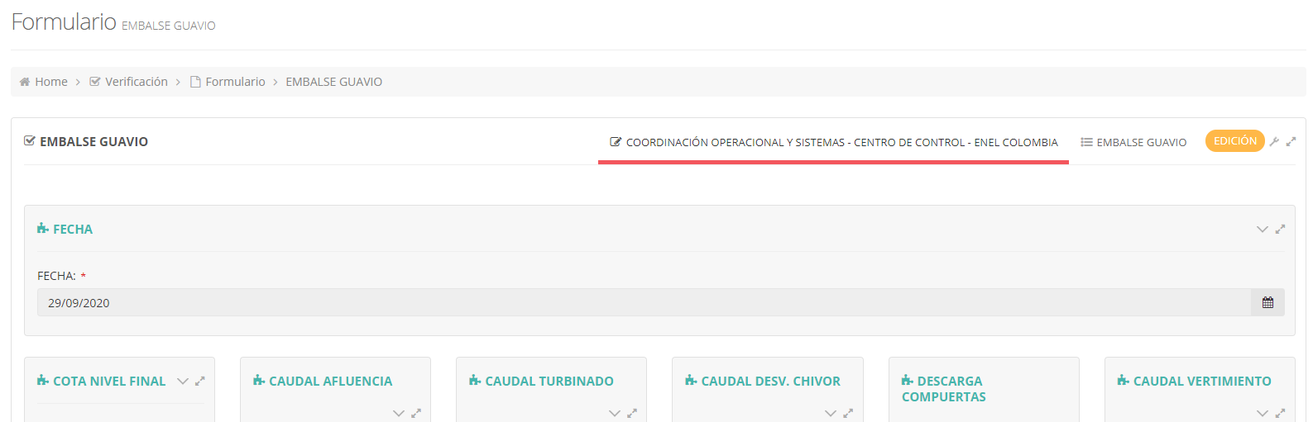

Los CMI donde debe verse reflejado de la interfaz este dato de caudal son:





Se debe ajustar un campo para que se muestre este dato:



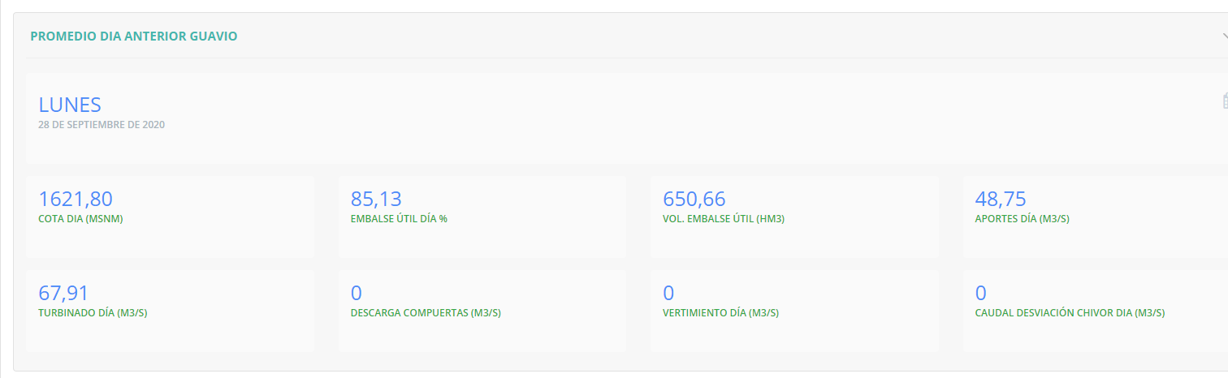

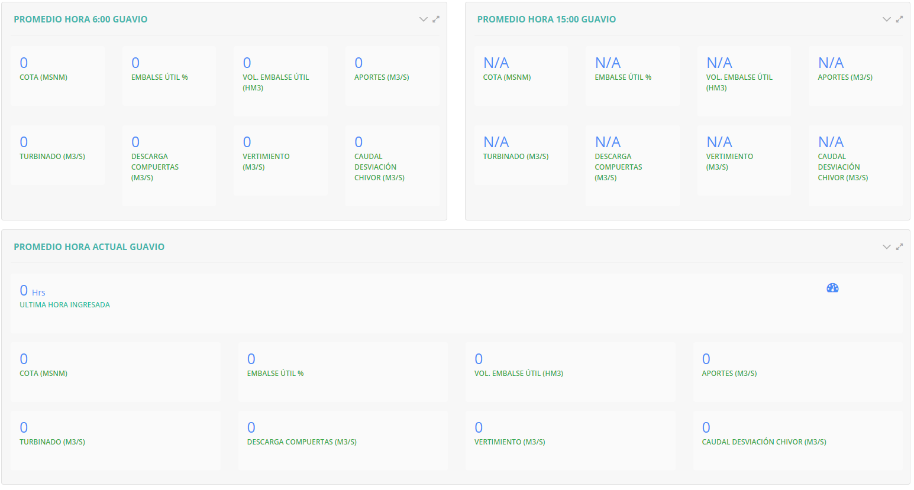

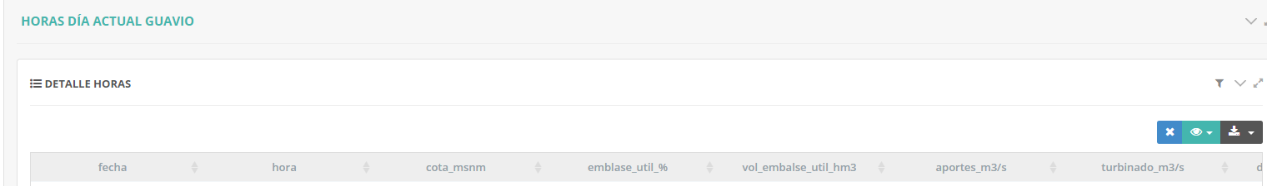



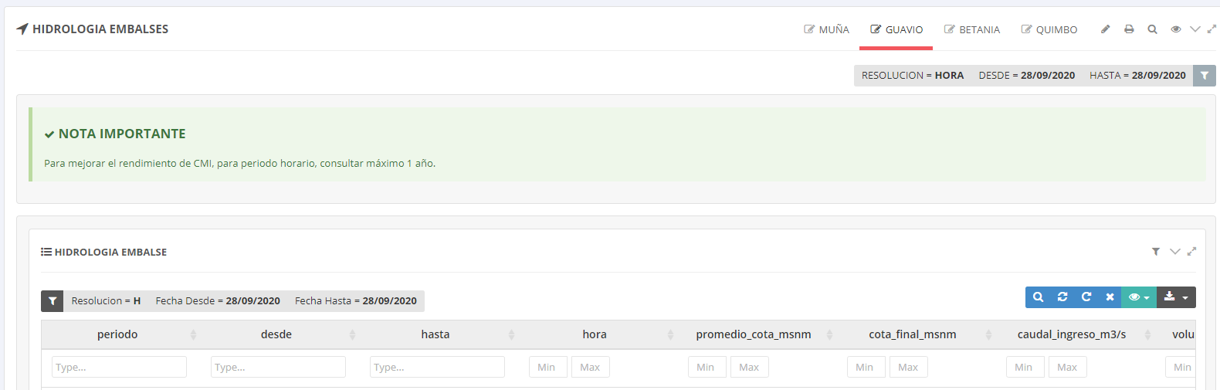

Los reportes donde debe verse reflejado este dato de caudal y de volumen son:

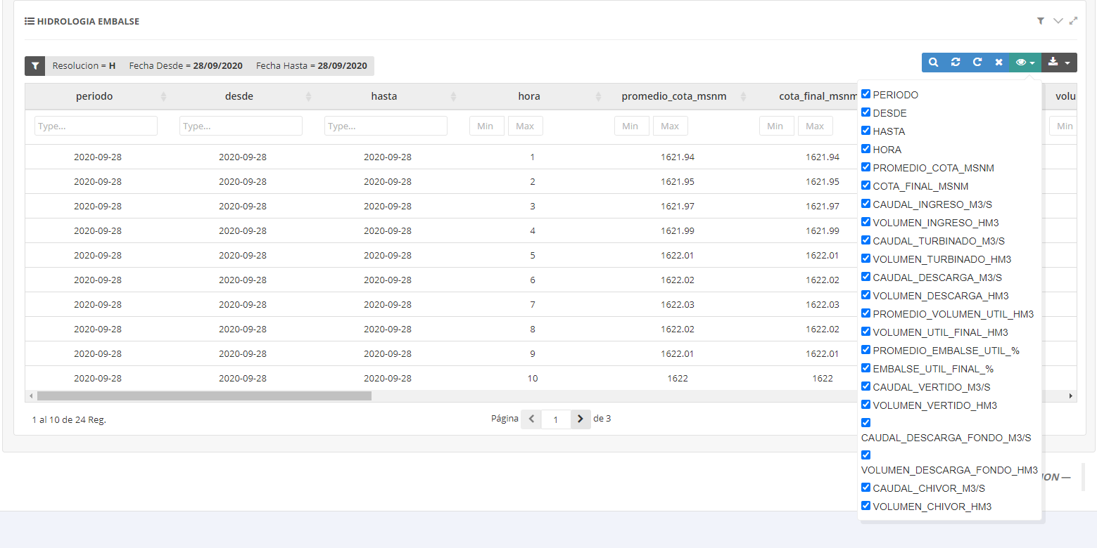

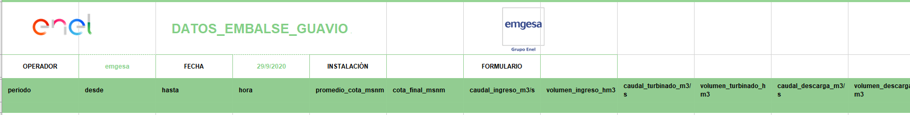

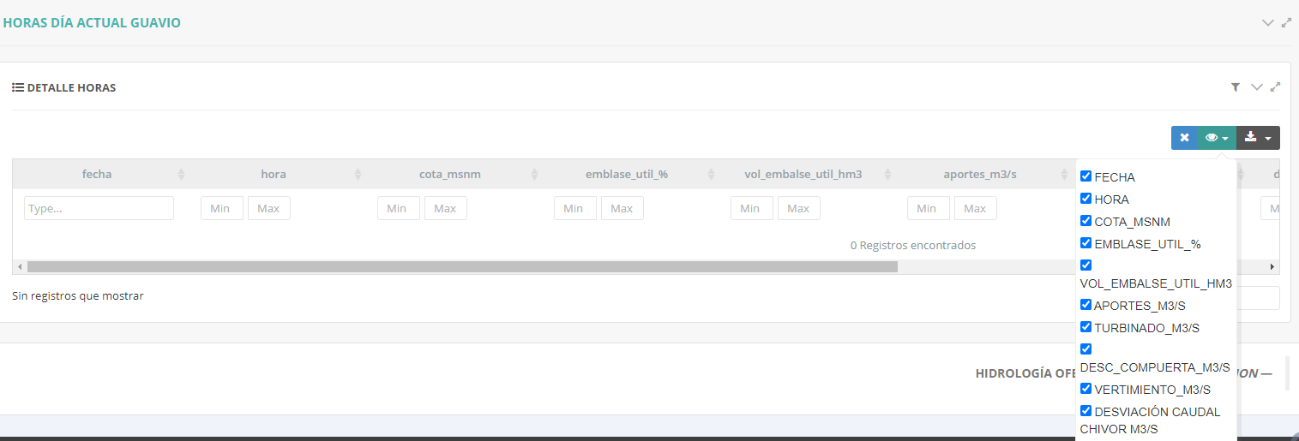

La funcionalidad debe ser:

1. Conectarse a la interfaz del sistema InGEN
2. Incluir la nueva variable de caudal indicada para que pueda traer los datos
3. Incluir la variable en nueva tabla para ir almacenando los datos
4. Incluir este nuevo campo en los CMI de hidrología
5. Incluir el dato en las columnas de los archivos que se extraen los reportes
6. Incluir el campo en el formulario para carga manual por contingencia
7. Antes de almacenar la información, se debe realizar un proceso de validación
8. El proceso debe generar un log con los registros procesados con éxito y mostrar la causa de fallo de aquellos que no se almacenaron.
9. Pruebas antes de paso a productivo

Para esto es necesario reunirse con Cesar Ramirez.

## Non-Functional Requirements

*List of non-functional requirements. After filling in the table, each requirement has to be described in detail for the purpose of estimating the preliminary effort.*

### Interfaces Requirements

*List of interface requirements. After filling in the table, each requirement has to be described in detail for the purpose of estimating the preliminary effort.*

|  |  |
| --- | --- |
| **Requirement ID** | **Requirement** |
|  |  |
|  |  |

### Migration Requirements

*List of migration requirements. After filling in the table, each requirement has to be described in detail for the purpose of estimating the preliminary effort.*

|  |  |
| --- | --- |
| **Requirement ID** | **Requirement** |
|  |  |
|  |  |

### Legal Requirements

*List of legal requirements (such as Data Protection Laws). After filling in the table, each requirement has to be described in detail for the purpose of estimating the preliminary effort.*

|  |  |
| --- | --- |
| **Requirement ID** | **Requirement** |
|  |  |
|  |  |

### Security Requirements

|  |  |
| --- | --- |
| **Requirement ID** | **Requirement** |
| S01 | Política de Ciberseguridad de Enel |
|  |  |

### Infrastructure Requirements

*List of infrastructure requirements. After filling in the table, each requirement has to be described in detail for the purpose of estimating the preliminary effort.*

|  |  |
| --- | --- |
| **Requirement ID** | **Requirement** |
|  |  |
|  |  |

### Operation Requirements

*List of operation requirements. After filling in the table, each requirement has to be described in detail for the purpose of estimating the preliminary effort.*

|  |  |
| --- | --- |
| **Requirement ID** | **Requirement** |
|  |  |
|  |  |

### Ergonomic Requirements

*List of ergonomic requirements. After filling in the table, each requirement has to be described in detail for the purpose of estimating the preliminary effort.*

|  |  |
| --- | --- |
| **Requirement ID** | **Requirement** |
|  |  |
|  |  |

### Training Requirements

*List of training requirements. After filling in the table, each requirement has to be described in detail for the purpose of estimating the preliminary effort.*

|  |  |
| --- | --- |
| **Requirement ID** | **Requirement** |
|  |  |
|  |  |

### Support Requirements

*List of support requirements. After filling in the table, each requirement has to be described in detail for the purpose of estimating the preliminary effort.*

|  |  |
| --- | --- |
| **Requirement ID** | **Requirement** |
|  |  |
|  |  |

### Other Non-Functional Requirements

*List of other non-functional requirements. After filling in the table, each requirement has to be described in detail for the purpose of estimating the preliminary effort.*

|  |  |
| --- | --- |
| **Requirement ID** | **Requirement** |
|  |  |
|  |  |

# Phasing Strategy

Las fases de implementación, así como la identificación del MVP (Mínimo Producto viable) se identificarán después del levantamiento de los requerimientos funcionales en detalle; aunque de manera preliminar se establece:

|  |  |  |  |
| --- | --- | --- | --- |
| **Phase** | **Requirements** | **Coverage** | **Functionality** |
|  |  |  |  |

Table 7 – Phasing Strategy

El MPV debe realizarse cumpliendo las políticas de ciberseguridad de Enel y lo reglamentado en el documento “ITS man​aged technologies v3​”.

# Peer-Review Strategy

*If the project will count with external resources, introduce the Peer-Review strategy to be followed in order to ensure the quality and integrity of the coverage of the different User Requirements. Specific Peer-Review activities should be provided, along with the main responsibilities of each “Peer”. If the project is going to be carried out with internal resources, this section appears in the SM200 template. Fill this section only if it applies to the project.*

# Constraints

* Este requerimiento o desarrollo evolutivo se debe realizar en la aplicación GREPORTING en su alcance Power Generation sin afectar las funcionalidades existentes, ni afacteras las funcionalidades del alcance Energu Management (Trading)..
* Se deben respetar las políticas laborales, de cybersecurity y reglamentación de sistemas y aplicaciones de Enel.

## Documentation Constraints

La documentación del Proyecto debe contener:

* Historia de Usuario

## Business Constraints

No se ha identificado ninguno hasta esta etapa.

## Technical Constraints

No se ha identificado ninguno hasta esta etapa.

## Premisas

No se ha identificado ninguno hasta esta etapa.

# Segregation of Duties

En la solución planteada en fases posteriores se analizará sí la herramienta digital requiere Segregación de funciones. Por le momento no se ha identificado.

|  |  |
| --- | --- |
| Affected Processes | Affected Systems |
|  |  |
|  |  |
|  |  |

*Once the list is completed, please, email it to:* [Ict.spring@enel.com](https://webmail.indra.es/owa/redir.aspx?SURL=603Bgl6mfYf7ABJHV1SNt4yTOYllSbhX8fyMewIUbisWB3YSoIjTCG0AYQBpAGwAdABvADoASQBjAHQALgBzAHAAcgBpAG4AZwBAAGUAbgBlAGwALgBjAG8AbQA.&URL=mailto%3aIct.spring%40enel.com)

# Annexes

**Lista de Parámetros V2.xlsx** **:** Listado de parámetros temporales y Atemporales que deben ser detallados y configurados en el sistema. El listado no es definitivo y en el levantamiento se pueden adicionar o excluir parámetros.

# Standards and Tips

*All sections of this template may or may not be filled with information, depending on the nature of the project. Whenever a section does not apply to the project, the user will indicate “Not Applicable” in the body of the section, in order to indicate that the section provides no   
required information for the specific project.  
  
Where possible, it is suggested the use of the following UML standard diagrams*

* *Use cases diagram*
* *Component diagram*
* *Functional diagram*
* *Activity diagram*
* *Deployment diagram*

Index of tables

Tables

Table 1 – Version Control 3

Table 2 – Definitions, acronyms, abbreviations 5

Table 3 – Glossary 6

Table 4 – Requester 8

Table 5 – Requirements Sheet 10

Table 6 – Relations with other Systems 10

Table 7 – Phasing Strategy 16